Lab 05:
Question#01:
CODE:
#include <iostream>
using namespace std;

class BaseClass {
private:
int privateInt;
protected:
int protectedInt;
public:
int publicInt;

void setPrivateInt(int value) {
privateInt = value;
}

void setProtectedInt(int value) {
protectedInt = value;
}

void setPublicInt(int value) {
publicInt = value;
}

int getPrivateInt() {
return privateInt;
}

int getProtectedInt() {
return protectedInt;
}

int getPublicInt() {
return publicInt;
}

};

class PublicClass : public BaseClass {
public:
void display() {
protectedInt = 20; // Accessible
publicInt = 30; // Accessbile
// privateInt = 40; // Not Accessible

cout << "ProtectedInt = " << protectedInt << endl;
cout << "PublicInt = " << publicInt << endl;
}
};

class ProtectedClass : protected BaseClass {
public:
void display() {
protectedInt = 40; // Accessible
publicInt = 50; // Accessible
// protectedInt = 60; // Not Accessible

cout << "ProtectedInt = " << protectedInt << endl;
cout << "PublicInt = " << publicInt << endl;
}
};

class PrivateClass : private BaseClass {
public:
void display() {
protectedInt = 60; // Accessible
publicInt = 70; // Accessible
// protectedInt = 80; // Not Accessible

cout << "ProtectedInt = " << protectedInt << endl;
cout << "PublicInt = " << publicInt << endl;
}
};

int main() {
PublicClass obj1;

obj1.setPrivateInt(10);
obj1.setProtectedInt(20);
obj1.setPublicInt(30);

cout << "Accessing PrivateInt using getter: " << obj1.getPrivateInt() << endl; // Accessible using getters

obj1.display();

cout << "------------------------------" << endl;

ProtectedClass obj2;
obj2.display(); // obj2 setPublicInt is not accessible outside the class as it is protected.

cout << "------------------------------" << endl;

PrivateClass obj3;
obj3.display(); // obj3 setPublicInt is not accessible as it is now private.

return 0;
}

OUTPUT:
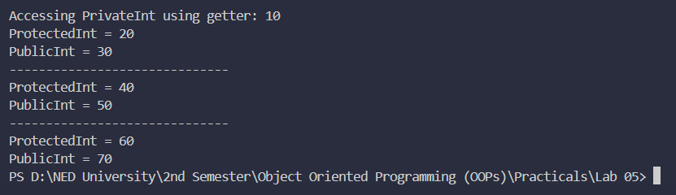

Question#02:
CODE:
#include <iostream>
using namespace std;

class Teacher {
protected:
string Name;
int Age;
string Institute;

public:
// Setters
void setName(string name) {
Name = name;
}

void setAge(int age) {
Age = age;
}

void setInstitute(string institute) {
Institute = institute;
}

// Getters
string getName() {
return Name;
}

int getAge() {
return Age;
}

string getInstitute() {
return Institute;
}
};

class HumanitiesTeacher : public Teacher {
private:
string Department = "Humanities";
string CourseName;
string Designation;

public:
void setCourseName(string course) {
CourseName = course;
}

void setDesignation(string designation) {
Designation = designation;
}

void display() {
cout << "\n--- Humanities Teacher ---\n";
cout << "Name: " << Name << endl;
cout << "Age: " << Age << endl;
cout << "Institute: " << Institute << endl;
cout << "Department: " << Department << endl;
cout << "Course Name: " << CourseName << endl;
cout << "Designation: " << Designation << endl;
}
};

class ScienceTeacher : public Teacher {
private:
string Department = "Science";
string CourseName;
string Designation;

public:
void setCourseName(string course) {
CourseName = course;
}

void setDesignation(string designation) {
Designation = designation;
}

void display() {
cout << "\n--- Science Teacher ---\n";
cout << "Name: " << Name << endl;
cout << "Age: " << Age << endl;
cout << "Institute: " << Institute << endl;
cout << "Department: " << Department << endl;
cout << "Course Name: " << CourseName << endl;
cout << "Designation: " << Designation << endl;
}
};

class MathsTeacher : public Teacher {
private:
string Department = "Maths";
string CourseName;
string Designation;

public:
void setCourseName(string course) {
CourseName = course;
}

void setDesignation(string designation) {
Designation = designation;
}

void display() {
cout << "\n--- Maths Teacher ---\n";
cout << "Name: " << Name << endl;
cout << "Age: " << Age << endl;
cout << "Institute: " << Institute << endl;
cout << "Department: " << Department << endl;
cout << "Course Name: " << CourseName << endl;
cout << "Designation: " << Designation << endl;
}
};

int main() {

HumanitiesTeacher h;
ScienceTeacher s;
MathsTeacher m;

string name, institute, course, designation;
int age;

cout << "Enter Humanities Teacher Details:\n";
cout << "Name: ";
cin >> name;
cout << "Age: ";
cin >> age;
cout << "Institute: ";
cin >> institute;
cout << "Course Name: ";
cin >> course;
cout << "Designation: ";
cin >> designation;

h.setName(name);
h.setAge(age);
h.setInstitute(institute);
h.setCourseName(course);
h.setDesignation(designation);

cout << "\nEnter Science Teacher Details:\n";
cout << "Name: ";
cin >> name;
cout << "Age: ";
cin >> age;
cout << "Institute: ";
cin >> institute;
cout << "Course Name: ";
cin >> course;
cout << "Designation: ";
cin >> designation;

s.setName(name);
s.setAge(age);
s.setInstitute(institute);
s.setCourseName(course);
s.setDesignation(designation);

cout << "\nEnter Maths Teacher Details:\n";
cout << "Name: ";
cin >> name;
cout << "Age: ";
cin >> age;
cout << "Institute: ";
cin >> institute;
cout << "Course Name: ";
cin >> course;
cout << "Designation: ";
cin >> designation;

m.setName(name);
m.setAge(age);
m.setInstitute(institute);
m.setCourseName(course);
m.setDesignation(designation);

h.display();
cout << "------------------------------" << endl;
s.display();
cout << "------------------------------" << endl;
m.display();

return 0;
}

OUTPUT:
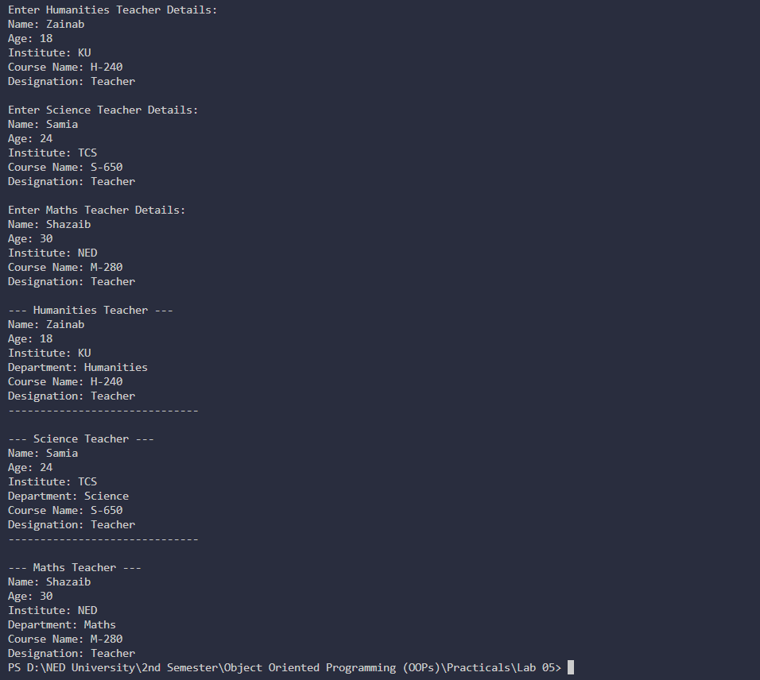

Question#03:
CODE:
#include <iostream>
using namespace std;

class Weapons {
public:
void WeaponsDescription() {
cout << "Weapons are tools which are used to cause damage or destruction. Sometimes they are used in self=defense." << endl;
}
};

class HotWeapons : public Weapons {
public:
void HotWeaponsDescription() {
cout << "Hot weapons use gunpowder, heat, or explosive materials to function." << endl;
}
};

class Bombs : public HotWeapons {
public:
void BombsDescription() {
cout << "Bombs are explosive weapons that blow up targets. i.e Grenades, Mines etc." << endl;
}
};

class NuclearBombs : public Bombs {
public:
void NuclearBombsDescription() {
cout << "Nuclear bombs cause massive explosions using nuclear fission and fusion." << endl;
}
};

int main() {

NuclearBombs nb;

// Because of multilevel inheritance,
// NuclearBombs can access all parent methods

nb.WeaponsDescription();
nb.HotWeaponsDescription();
nb.BombsDescription();
nb.NuclearBombsDescription();

return 0;
}

OUTPUT:
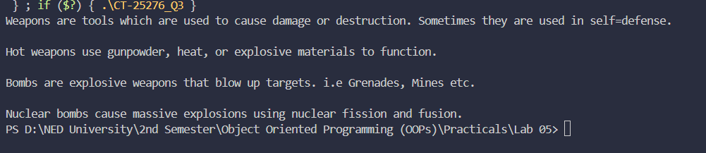

Question#04:
CODE:
#include <iostream>
using namespace std;

// ================= Base Class =================
class Item {
protected:
string Name;
int Quantity;

public:
void setItem(string name, int qty) {
Name = name;
Quantity = qty;
}

string getName() {
return Name;
}

int getQuantity() {
return Quantity;
}
};

class BakedGoods : public Item {
protected:
double discount = 0.10;

public:
double applyDiscount(double total) {
return total - (total * discount);
}
};

class Cakes : public BakedGoods {
private:
double price = 600;

public:
double calculateBill() {
double total = price * Quantity;
return applyDiscount(total);
}
};

class Bread : public BakedGoods {
private:
double price = 200;

public:
double calculateBill() {
double total = price * Quantity;
return applyDiscount(total);
}
};

class Drinks : public Item {
private:
double price = 100;
double discount = 0.05;

public:
double calculateBill() {
double total = price * Quantity;
return total - (total * discount);
}
};

int main() {

int choice, qty;
string name;

while (true) {
cout << "Select Item:\n";
cout << "1. Cake (600, 10% discount)\n";
cout << "2. Bread (200, 10% discount)\n";
cout << "3. Drink (100, 5% discount)\n";
cout << "4. Exit\n";
cout << "Enter choice: ";
cin >> choice;

if (choice == 4 ) {
cout << "Exiting..." << endl;
break;
}

if (choice < 1 || choice > 4) {
cout << "Invalid choice. " << endl;
continue;
}

cout << "Enter quantity: ";
cin >> qty;

if (choice == 1) {
Cakes c;
c.setItem("Cake", qty);
cout << "Total Bill: " << c.calculateBill() << "\n" << endl;
}
else if (choice == 2) {
Bread b;
b.setItem("Bread", qty);
cout << "Total Bill: " << b.calculateBill() << "\n" << endl;
}
else if (choice == 3) {
Drinks d;
d.setItem("Drink", qty);
cout << "Total Bill: " << d.calculateBill() << "\n" << endl;
}

}

return 0;
}

OUTPUT:
